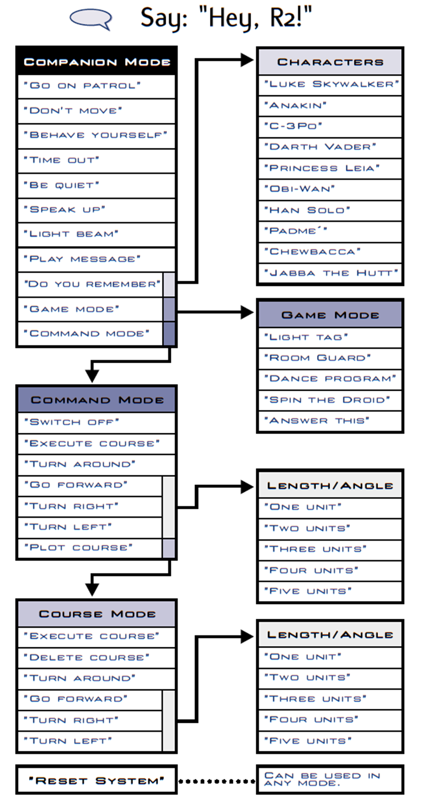
R2 Secret Commands：
#1 - Follow Me
“Follow Me”

#2 - Come Here
“Come Here”

#3 - Imperial March Song
"Do You Remember”. “Darth Vader”
"Do You Remember”
“Anakin”

#4 - Sad Cantina Song
“Do You Remember”
“Darth Vader”
“Game Mode”
“Dance Program”

#5 - Celebration Song
"Do You Remember” “Chewbacca”
"Do You Remember”
“Han Solo”
"Do You Remember”
“Luke Skywalker”

#6 - A "Special Surprise"
"Light Beam”.
Tap Interactive R2D2 three times on the head.
"Game Mode"
"Dance program”

#7 - See R2-D2's Reactions
Good reactions:
"Master Windu"
"Master Yoda"
"Qui-Gon Jinn"

Scared reactions:
"the Death Star"
"Tuscan Raiders"
"the Star Destroyer"
"the Landspeeder"
"Darth Plagus"
"Darth Maul"
"Darth Sidious"
"Darth Tyranus"
"the Empire"-he played the Imperial March once, too
"the Cantina"
"the Sandcrawler"
"Jabba's Sandbarge"
"Jango Fett" and, believe it or not"

